Pear Tree Primary School incorporating Pips Before and After School Club

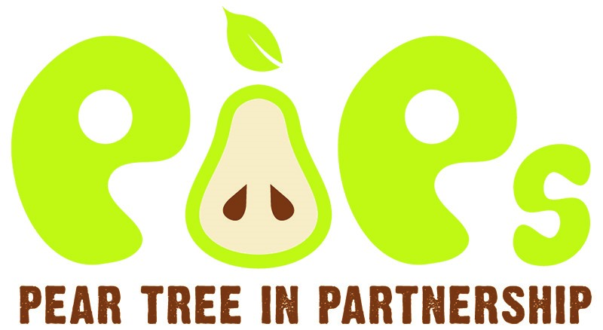

Forest School Policy

Date agreed | November 2024
Date for Review | September 2027  (Or sooner if required)
Reviewed by: | Matthew Greasby
Acting Headteacher | Mr M Greasby
Chair of Governors | Dr J Hillman
Signed on behalf of the Governors’ Board by:  Name: | Signature:  Date:
Signed on behalf of the school by:  Matthew Greasby  Acting Headteacher | Signature:  Date:

Statement of Intent

Pear Tree Primary School aims to use the natural outdoor area to offer the children an insight into the Forest School ethos. This approach to outdoor learning encourages children to become independent, use their imagination, take appropriate risks within boundaries and initiate learning for themselves. Forest School is a holistic approach to learning, incorporating children’s individuality and develops their skills for lifelong learning. It can cover all aspects of learning, supporting the growth of self-esteem and self-confidence as well as helping children to form positive relationships with their peers and the adults in school. Forest School explores the outdoors and the natural environment with practical, useful activities all year round. It develops peer learning with the adults providing support and enabling activities to take place. The child’s interests are placed at the heart of all activities.

Legislation considered for this policy

Health and Safety at Work Act 1974
Disability Discrimination Act 2005
Race Relations Acts 1976 & 2000
Sex Discrimination Act 1986
Special Educational Needs and Disability Act 2001
Children Act 2004

All existing Pear Tree Primary School policies will be adhered to alongside this policy during Forest School sessions.

Implementation

Risk assessments, good practice, Forest School activities, rules for tools and fire etc. can all be found within the Forest School File - held by the Forest School Lead. This contains everything needed for Forest School sessions (procedures, risk assessments, environmental impacts etc.)

Equality and Diversity: All children will be included with all activities and no form of discrimination will take place, reasonable adjustments will be made to make it inclusive for all. Inclusion is a thread running through all of the Forest School activities regardless of a child’s ability, disability, gender, race, culture, etc. Pear Tree Primary School has an Inclusion, Special Educational Needs Policy and an Equality and Diversity Policy, all of which will be adhered to during Forest School sessions.

Health and Safety: Forest School sessions by their nature encourage children to develop their own risk management skills and will support them to become responsible for themselves and others around them. Children will be reminded of rules and safe play at the beginning of each session. Reminders will be given and a variety of sanctions applied for dangerous behaviour, in line with the school’s behaviour policy. Ratios within the woodland area remain the same as indoors as we are still on the school premises. Risk assessments will be carried out before each visit and for the use of all tools and equipment. Dynamic risk assessments will be in place to cover other eventualities. The Forest School Leader will assess weather conditions regularly and will evacuate the area if they become too extreme. All children and adults will wear appropriate clothing depending upon the weather conditions. An open fire risk assessment will be carried out before a fire is allowed and protection procedures followed. A Forest School Leader will be present at all times and children will be reminded of safe practice. Relevant school policies such as Health and Safety Policy, Safeguarding Children Policy will be adhered to at all times.

Risk Assessments will include:
- The site of the Forest School
- Individual Risk Assessments for tools (bill hook, bow saw, mallets, knives)
- Open Fire
- Rope and string
- Shelter building
- Collecting natural materials

First Aid: All Forest School Leaders are First Aid trained and some have specific additional outdoor qualifications. The Forest School Leader is responsible for ensuring the safety of all children within the group and that all staff are aware of specific medical conditions. The Forest School Leader is responsible for ensuring a first aid kit is taken out for every session and includes epi-pens, inhalers and any other relevant emergency medication. Additional first aid boxes and supplies are located within the school. The Forest School leader is also responsible for ensuring emergency procedures are followed, should the need arise, as per school policy.

Use of Tools
Children and adults will be trained in the use of each tool before they use it. Tools will be counted in and out and checked against an inventory. Tools will be stored safely and kept out of the reach of children. They will be cleaned after each use to prolong their life, broken and damaged tools will not be used and in line with Covid cleaning procedures. Children and adults will be informed of rules, safety and how to use before they use. Tool use will be on a ratio of one to one.

Use of Fires
A Forest School Leader must always be present when a fire is lit and it must never be left unattended. There must always be water available to extinguish the fire.

Children will be reminded of the fire pit procedures at each and every visit.
- Walk behind the sleeper seats and stand behind the sleepers.
- Step over and sit down on the sleeper seats.
- Stand up, turn around and step over the sleepers.
- Children are not allowed to cross the inner fire circle (adults should be role models of this).

Environment: Wherever possible environmentally friendly products and recycled materials will be used. Pear Tree Primary School will promote environmental awareness and care for our environment. Conservation issues and sustainability will also be supported. The woodland will be maintained to ensure the survival of all native flora and fauna and new flora will be introduced if needed. We will remove all litter and debris we take into the woodland and have regular litter picks to remove other refuse from the area. We will be caring towards our neighbours and try to minimise the amount of smoke and noise produced. Brambles and nettles will be removed from main pathways but will be allowed to grow in other areas of the woodland. Branches at eye level and below on main pathways will be removed to avoid injuries for people entering the woodland but they will remain on all other trees. Dead and fallen branches will be cut and stored as either fire wood or as a den building resource. During the winter months large stones and logs will be left alone to avoid disturbing hibernating creatures. There will be areas created where wood is allowed to rot to encourage insects to thrive, wild flowers will be allowed to grow and children encouraged to enjoy them growing rather than pick them. The hedgerows will be maintained to provide an additional habitat for wildlife.

Roles and Responsibilities:
Forest School Leader: will have a level 3 Forest School Leader qualification, DBS enhanced disclosure and a first aid qualification.

Forest School Leader will have the overall responsibility for:
- Risk assessments for each session, pre-visit site checks and continuous safety
monitoring.
- Planning for sessions, differentiation for individual children’s needs.
- Ensuring necessary equipment is taken into woodland.
- Administration of first aid and first aid kit.
- Supervision of tools use, cleaning and storing.
- Organising emergency procedures.

Staff/ students / volunteers: will model good practice throughout the session, carry out delegated roles and responsibilities, extend children’s learning where appropriate by asking extending questions, support children to manage their own risk, remind children of rules and boundaries, be aware of dangers within Forest School and monitor levels of safety at all times, support the Forest School leader to run the sessions.

Monitoring of policy

This policy will be reviewed annually or before should any incidents arise or laws and policies change.

