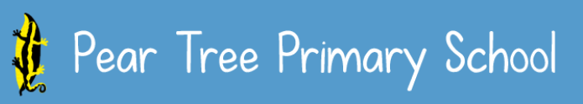

Art Curriculum Planning Long Term Plan Art
Being Our Best Selves
End points

 | Autumn Term | Spring Term | Summer Term
Year R  Artist - Megan Coyle | Drawing – Marvellous Marks | Painting and mixed media – Paint my World | Sculpture and 3D – Clay house (Dragon eyes)
Year 1  Artist - | Drawing – Make your mark | Painting and mixed media – Colour splash | Craft and Design - Woven wonders
Year 2  Artist - Picasso | Painting and mixed media – Life in colour (African art) | Drawing – with specific focus on Fire of London story | Sculpture and 3D – Clay house (Dragon eyes)
Year 3  Artist - | Painting and mixed media – Prehistoric painting | Drawing – Growing artists | Sculpture and 3D – Abstract , shape and space
Years 4  Artist – Jocelyn Barbara Hepworth, Sokari Douglas Camp | Craft and design: Ancient Egyptian scrolls | Drawing – Power prints | Sculpture and 3D – Mega materials
Year 5  Artist – Teis Albers | Drawing - I need space | Sculpture and 3D – Interactive instalation | Paints and mixed media - Portraits
Year 6  Artist – Edward Weston | Drawing – Make my voice heard | Craft and Design – Photo opportunity | Paints and mixed media – Artist study

