Music development plan summary:
Pear Tree Primary School

Overview
Detail | Information
Academic year that this summary covers | 2024 -25
Date this summary was published | September 2024
Date this summary will be reviewed | September 2025
Name of the school music lead | Debbie Swallow
Name of school leadership team member with responsibility for music (if different) | Ruth Hadfield
Name of local music hub | Love Music Trust
Name of other music education organisation(s) (if partnership in place) | Music for Life

This is a summary of how our school delivers music education to all our pupils across three areas – curriculum music, co-curricular provision and musical experiences – and what changes we are planning in future years. This information is to help pupils and parents or carers understand what our school offers and who we work with to support our pupils’ music education.

Part A: Curriculum music
This is about what we teach in lesson time, how much time is spent teaching music and any music qualifications or awards that pupils can achieve.
At Pear Tree Primary School our vision is to enable all children and young people to learn to sing, play an instrument and create music together, and have the opportunity to progress their musical interests and talents, including professionally. We want to see music valued and celebrated in every early years setting and school. Schools should deliver high-quality curriculum music for at least one hour a week in The Foundation Stage, key stages 1 and 2, supported by co-curricular learning, and musical experiences.
Our vision is to enable all children and young people to learn to sing, play an instrument and create music together, and have the opportunity to progress their musical interests and talents, including professionally.
This means all children and young people:
• experience a broad musical culture in schools and education settings, accessing high-quality curricular and co-curricular music, and progressing into appropriate qualifications
• access the expertise, instruments, technology and facilities they need to learn, create and share their music
• engage with a range of enrichment opportunities to play and sing, to perform, create and experience live music, and have their music heard
• have opportunities to progress their musical interests and talents, and routes into a variety of music careers
• are supported by a skilled and dynamic workforce.
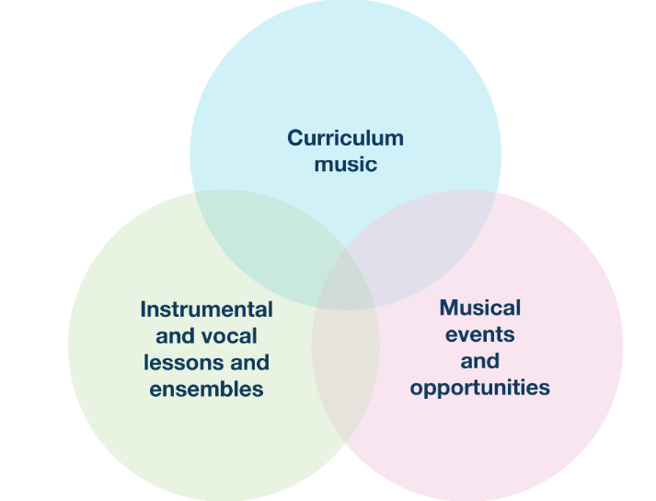
These are our features of high quality music at Pear Tree Primary School …
Features of high quality music | Who | When
Timetables curriculum music of at least one hour each week. | Foundation Stage, Key Stage 1 and Key Stage 2 | Weekly taught music session and whole school singing assembly.
Access to lessons across a range of instruments and voice | Love Music Trust (Hub school) curriculum) | Weekly taught session
A school choir | year 1 – 6 | every Monday after school
A school ensemble/ band/ group
Space for rehearsals and practice | Foundation Stage, Key Stage 1 and Key Stage 2 | Classrooms, sun/ moon/ planet suite
A termly school performance | - Foundation Stage, Key Stage 1 and Key Stage 2 | Autumn Term – Christmas Nativity/ performance  Spring Term – Class assembly with an element of either singing or music – based on taught units during the Spring Term  Summer Term – End of year showcase whole school singing and music celebration
Opportunities to enjoy a live performance | - Foundation Stage, Key Stage 1 and Key Stage 2 | Autumn Term – Christmas Nativity/ performance. Helen Minshall music extravaganza.  Spring Term – Class assembly with an element of either singing or music – based on taught units during the Spring Term. Brass Assembly (Year 4) Violin Assembly (Year 3) Helen Minshall music extravaganza. Young Voices (ks2 choir)  Summer Term – End of year showcase whole school singing and music celebration. Helen Minshall music extravaganza. The Halle at Bridgewater Hall (ks2 choir and instrumental)
Opportunities to learn a music instrument | Year 3 and 4 | Spring term – Brass in Year 4 and Violin in Year 3
Partnerships with local hubs and skilled and dynamic workforce. | - Foundation Stage, Key Stage 1 and Key Stage 2 | Spring term – Brass in Year 4 and Violin in Year 3.  Curriculum and expertise from Love Music Trust.  Halle  Young Voices  Helen Minshall music extravaganza – termly.

Part B: Co-curricular music
This is about opportunities for pupils to sing and play music, outside of lesson time, including choirs, ensembles and bands, and how pupils can make progress in music beyond the core curriculum.
Outlined below are the extra curricular opportunities available for pupils at Pear Tree Primary School.
Extra Curricular opportunities for pupils: | Who | When
Whole School Singing Assembly | Foundation Stage, Key Stage 1 and Key Stage 2 | Weekly Thursday mornings
A school choir | Year 1 – 6 | Every Monday after school
A school ensemble/ band/ group
Space for rehearsals and practice | Foundation Stage, Key Stage 1 and Key Stage 2 | Classrooms, sun/ moon/ planet suite
A termly school performance | - Foundation Stage, Key Stage 1 and Key Stage 2 | Autumn Term – Christmas Nativity/ performance  Spring Term – Class assembly with an element of either singing or music – based on taught units during the Spring Term  Summer Term – End of year showcase whole school singing and music celebration
Opportunities to enjoy a live performance | - Foundation Stage, Key Stage 1 and Key Stage 2 | Autumn Term – Christmas Nativity/ performance. Helen Minshall music extravaganza.  Spring Term – Class assembly with an element of either singing or music – based on taught units during the Spring Term. Brass Assembly (Year 4) Violin Assembly (Year 3) Helen Minshall music extravaganza. Young Voices (ks2 choir)  Summer Term – End of year showcase whole school singing and music celebration. Helen Minshall music extravaganza. The Halle at Bridgewater Hall (ks2 choir and instrumental)
Opportunities to learn a music instrument | All Year 3 and 4 | Spring term – Brass in Year 4 and Violin in Year 3
Opportunities to continue to learn a musical instrument | Key Stage 2 pupils | Lessons through Music for Life currently include: piano. Keyboard, violin, cornet, trumpet, guitar, clarinet.  Included is loans of musical instruments for the first term. Tuition is subsidised or free, including for parents or carers in particular circumstances (e.g. pupil premium eligibility).
Partnerships with local hubs and skilled and dynamic workforce. | - Foundation Stage, Key Stage 1 and Key Stage 2 | Spring term – Brass in Year 4 and Violin in Year 3.  Curriculum and expertise from Love Music Trust.  Halle  Young Voices  Helen Minshall music extravaganza – termly.

Part C: Musical experiences
This is about all the other musical events and opportunities that we organise, such as singing in assembly, concerts and shows, and trips to professional concerts.
Extra Curricular opportunities for pupils: | Who | When
Whole School Singing Assembly | Foundation Stage, Key Stage 1 and Key Stage 2 | Weekly Thursday mornings
Singing at Nantwich Museum to the elderly | Year 3– 6 | Autumn Term
Christmas Nativity/ performance | Foundation Stage, Key Stage 1 and Key Stage 2 | Autumn Term
Class assembly with an element of either singing or music – based on taught units during the Spring Term | Foundation Stage, Key Stage 1 and Key Stage 2 | Spring Term
End of year showcase whole school singing and music celebration | Foundation Stage, Key Stage 1 and Key Stage 2 | Summer
Helen Minshall day – with performance at the end of the day | Foundation Stage, Key Stage 1 and Key Stage 2 | Every term
Young Voices | Key Stage 2 Choir | Spring term
Come and Play with Halle | Key Stage brass and choir | Summer term
Carols at the local Church | Year 5 and 6 | Autumn Term
Opportunities to learn a music instrument | All Year 3 and 4 | Spring term – Brass in Year 4 and Violin in Year 3
Betty/Barnaby Bear | Year 1 | Spring Term
Opportunities to continue to learn a musical instrument | Key Stage 2 pupils | Lessons through Music for Life currently include: piano. Keyboard, violin, cornet, trumpet, guitar, clarinet.  Included is loans of musical instruments for the first term. Tuition is subsidised or free, including for parents or carers in particular circumstances (e.g. pupil premium eligibility).
Partnerships with local hubs and skilled and dynamic workforce. | - Foundation Stage, Key Stage 1 and Key Stage 2 | Spring term – Brass in Year 4 and Violin in Year 3.  Curriculum and expertise from Love Music Trust.  Halle  Young Voices  Helen Minshall music extravaganza – termly.

In the future
This is about what the school is planning for subsequent years.
The most important thing is developing our music curriculum is to incorporate a band/ ensemble or group. December 2024
Increase the uptake of music lessons for pupils identified as Young Carers or Pupil Premium. June 2024
To increase taught lesson time to an hour a week in all classes across the school. December 2024

Further information (optional)
The Department for Education publishes a guide for parents and young people on how they can get involved in music in and out of school, and where they can go to for support beyond the school.
Our local music hub is Love music trust. You can find more information here. This includes their plan to develop music locally.

