

**Results Summary July 2022**

**Year 1 Phonics Screening Test Results**

**National Average 2019 to reach expected Phonics level = 82%**

**2021 = 82%**

|  |  |
| --- | --- |
| **Number/% of pupils not on track to achieve pass in Yr. 1 phonics:** | **Number/% of pupils on track to achieve pass mark in Yr. 1 phonics:** |
| **3/30**  **10%** | **27/30**  **90%** |

**Year 2**

**Our End of Year June 2022**

**National Average 2019 = 75% ARE + (26% EXCEEDING) – Reading**

**National Average 2019 = 69% ARE+ (15% EXCEEDING) - Writing**

**National Average 2019 = 69% ARE+ (22% EXCEEDING) - Maths**

|  |  |  |  |  |  |
| --- | --- | --- | --- | --- | --- |
|  | **Pre Key Stage** | **Working Towards**  **(WTS)** | **At Age Related Expectation (ARE)** | **Exceeding** | **% at or above EXS** |
| **Reading** | **2/30**  **6%** | **4/30**  **13%** | **20/30**  **67%** | **4/30**  **13%** | **24/30**  **80%** |
| **Writing** | **4/30**  **12%** | **10/30**  **34%** | **17/30**  **56%** |  | **17/30**  **56%** |
| **Maths** | **0/30**  **0%** | **8/30**  **27%** | **21/30**  **70%** | **1/30**  **3%** | **22/30**  **73%** |

**Year 4 Multiplication Test**

The multiplication tables check (MTC) is statutory for primary schools in the 2021/22 academic year.

The purpose of the MTC is to determine whether pupils can recall their times tables fluently, which is essential for future success in mathematics. It will help schools to identify pupils who have not yet mastered their times tables, so that additional support can be provided.

Schools must administer the MTC to all eligible year 4 pupils between Monday 6 June and Friday 24 June. There is no pass mark for the check.

|  |  |  |  |
| --- | --- | --- | --- |
| **Number/% of pupils who achieved 20+ correct responses out of 25 – June 2022.** | **Number/% of pupils who achieved 22+ correct responses out of 25 – June 22** | **Number/% of pupils who achieved full marks correct - June 22** | **Number of SEN Pupils achieved 20+** |
| **26/31 = 84%** | **19/31 = 61%** | **10/31 = 32%** | **5/8 = 63%** |

**Year 6 predicted end of year results for 2021/22 – June 2022**

**Reading Year 6 - PREDICTED**

|  |  |  |
| --- | --- | --- |
| **Number/% of pupils not on track to achieve ARE + by July 2022.** | **Number/% of pupils on track to achieve ARE by July 2022** | **Number/% of pupils on track to achieve exceeding by July 2022.** |
| **6/33 = 18%**  **National Average 2019 = 28%** | **22/33 = 67%**  **National Average 2019 = 73% (ARE+)** | **5/33 = 15% (Combined 82% = ARE+)** |

**Writing Year 6 - PREDICTED**

|  |  |  |
| --- | --- | --- |
| **Number/% of pupils not on track to achieve ARE + by July 2022.** | **Number/% of pupils on track to achieve ARE by July 2022.** | **Number/% of pupils on track to achieve exceeding by July 2022.** |
| **8/33 = 24%**  **National Average 2019 = 24%** | **24/33 = 73%National Average 2019 = 58%** | **1/33 = 3% (Combined 76% = ARE+)**  **National Average 2019 = 20%** |

**Maths Year 6 - PREDICTED**

|  |  |  |
| --- | --- | --- |
| **Number/% of pupils not on track to achieve ARE + by July 2022.** | **Number/% of pupils on track to achieve ARE by July 2022.** | **Number/% of pupils on track to achieve exceeding by July 2022.** |
| **6/33 = 18%**  **National Average 2019**  **25%** | **22/33 = 67%**  **National Average 2019**  **79% (ARE+)** | **5/33 = 15% (Combined 82% = ARE+)** |

**SPaG (Spelling, Punctuation and Grammar) Year 6 - PREDICTED**

|  |  |  |
| --- | --- | --- |
| **Number/% of pupils not on track to achieve ARE + by July 2022.** | **Number/% of pupils on track to achieve ARE by July 2022 .** | **Number/% of pupils on track to achieve exceeding by July 2022.** |
| **6/33 = 18%**  **National Average 2019**  **22%** | **20/33 = 61%**  **National Average 2019**  **78% (ARE+)** | **7/33 = 21% (Combined 82% = ARE+)** |

**Combined R/W/M = 70%**

**National Average 2019 65% combined**

**Year 6 ACTUAL end of year results for 2021/22 (Unvalidated)**

**Reading Year 6**

|  |  |  |
| --- | --- | --- |
| **Number/% of pupils who did not achieve ARE + by July 2022.** | **Number/% of pupils who achieved ARE by July 2022** | **Number/% of pupils on track to achieve exceeding by July 2022.** |
| **3/33 = 9%**  **National Average 2019 = 28%**  **School Result 2019 = 24%** | **15/33 = 45.5%**  **National Average 2019 = 73% (ARE+)**  **School Result 2019 = 45%** | **15/33 = 45.5% (Combined 91% = ARE+)**  **School Result 2019 = 31% (Combined 2019 = 76%)** |

**Writing Year 6**

|  |  |  |
| --- | --- | --- |
| **Number/% of pupils not on track to achieve ARE + by July 2022.** | **Number/% of pupils on track to achieve ARE by July 2022.** | **Number/% of pupils on track to achieve exceeding by July 2022.** |
| **7/33 = 21%**  **National Average 2019 = 24%**  **School Result 2019 = 21%** | **25/33 = 76%**  **National Average 2019 = 58%**  **School Result 2019 = 73%** | **1/33 = 3% (Combined 79% = ARE+)**  **National Average 2019 = 20%**  **School Result 2019 = 9% (Combined 2019 = 82%)** |

**Maths Year 6**

|  |  |  |
| --- | --- | --- |
| **Number/% of pupils who did not achieve ARE + by July 2022.** | **Number/% of pupils who achieved ARE by July 2022.** | **Number/% of pupils who achieved exceeding by July 2022.** |
| **4/33 = 12%**  **National Average 2019**  **25%**  **School Result 2019 = 21%** | **19/33 = 58%**  **National Average 2019**  **79% (ARE+)**  **School Result 2019 = 36%** | **10/33 = 30% (Combined 88% = ARE+)**  **School Result 2019 = 43% (Combined 2019 79%)** |

**SPaG (Spelling, Punctuation and Grammar) Year 6**

|  |  |  |
| --- | --- | --- |
| **Number/% of pupils who did not achieve ARE + by July 2022.** | **Number/% of pupils who achieved ARE by July 2022.** | **Number/% of pupils who achieved exceeding by July 2022.** |
| **1/33 = 3%**  **National Average 2019**  **22%**  **School Result 2019 = 18%** | **18/33 = 55%**  **National Average 2019**  **78% (ARE+)**  **School Result 2019 = 33%** | **14/33 = 42% (Combined 97% = ARE+)**  **School Result 2019 = 49 %( Combined 2019 = 82%)** |

**Combined R/W/M = 73%**

**National Average 2019 65% combined**

**School 2019 67% combined**

**Commentary (Taken from National Headlines Assessment release document)**

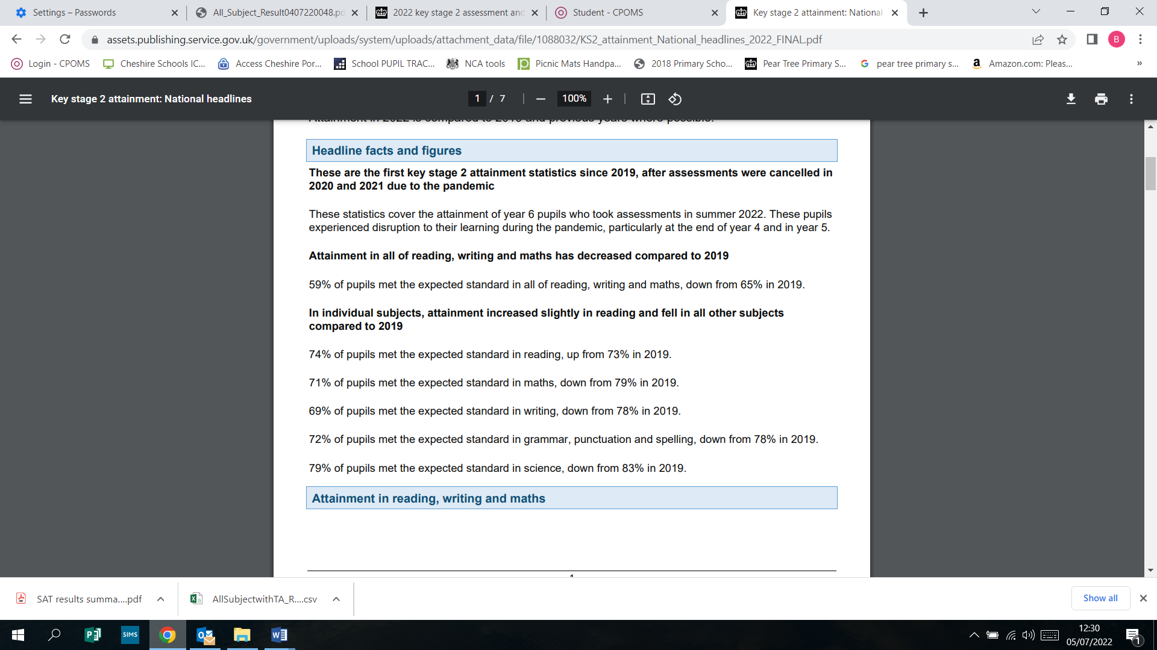

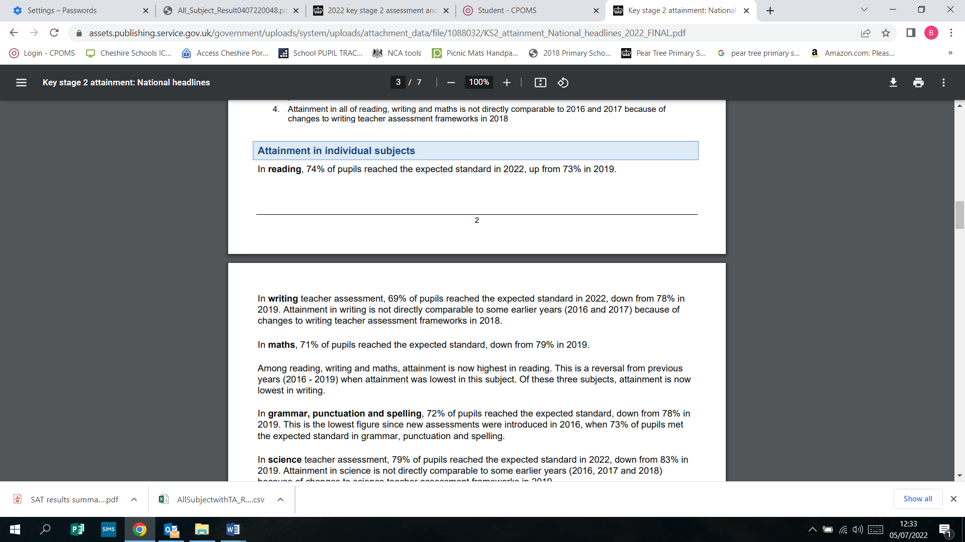

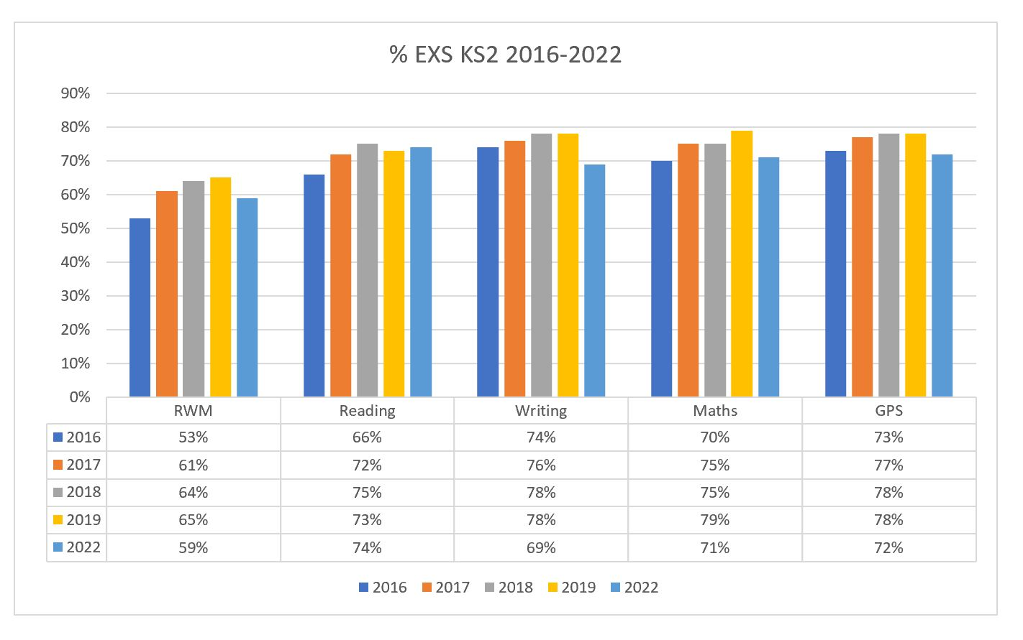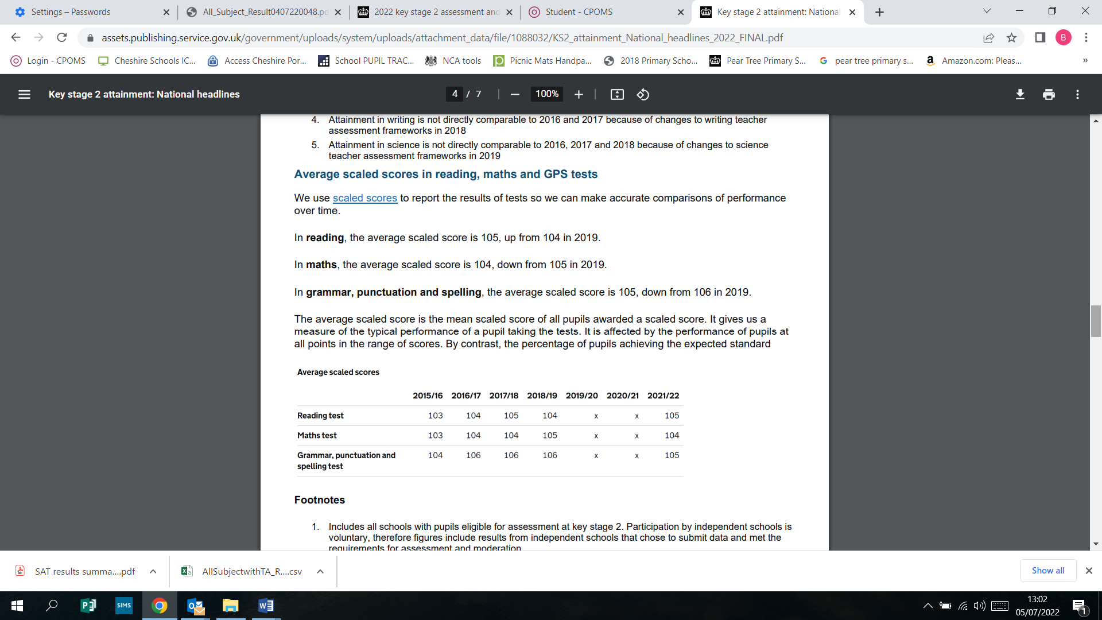

|  |  |  |  |
| --- | --- | --- | --- |
| **Average Scaled Scores (unvalidated) Pear Tree 2021/2022** | **Reading** | **Maths** | **Grammar Punctuation and Spelling** |
| **108** | **107** | **108** |
| **2018/19 (Last data pre-COVID)** | **105** | **107** | **108** |